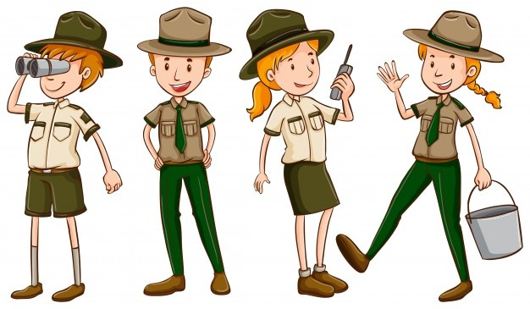

Welcome to the Martin Van Buren National Historic Site named Lindenwald.
It’s a beautiful place to walk around and enjoy nature.
Do you know the name of the person who once lived here and was the eighth President of the United States?
It’s Martin Van Buren, of course!
While visiting Lindenwald stop and say hello to the Park Rangers,
they are always happy to talk to visitors and answer any questions you may have.

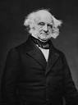 Martin Van Buren, 8th President of the United States.

Wee Wonders
Weather Journal Introduction

“Temperature, Clouds and Sun is Weather – Oh, my!”

A modern illustration of William Shakespeare by the Los Angeles Times.
Original engraving by: Martin Droeshout, 1623.

“To be or not to be” outside in flip flops when it’s snowing? That is the question.

Well, maybe not one Shakespeare asked, but you should, and that’s why it’s important to pay attention to the weather outside!

Did you know that weather is more than just one thing? How do you tell the difference?

You’ll find the answer to these questions and more as you complete the activities in your weather journal.

You’ll also learn a little bit about a man named Shakespeare -actually his first name was William, but Shakespeare is far more fun to pronounce.

So, join Shakespeare on a journey to learn how “temperature, clouds, and sun is weather –
Oh, my!”

 Wee Wonders Activity Guide for:
Temperature, Clouds, and Sun is Weather – Oh, my!

1. Read: Weather Journal Introduction.
2. Read: “Begin the Adventure”.

3. Listen to a story on YouTube about weather:
Story: “When Cloud Became a Cloud” by: Ron Hodgson
https://www.youtube.com/watch?v=EVJQm0ZTeIQ
4. Make your own:
‘Cloud Headband’
5. Find out what a Meteorologist does: Meteor Whaaaat?

6. Think and Predict: Tomorrow’s Weather

7. Conduct an experiment: ‘Cloud In a Jar’

8. Read and Learn about:
Martin Van Buren’s ‘Year Without a Summer.’

9. Express your creative side with:
A cloud capture, ‘En Plein Air’ style.

10. Test your knowledge with the: ‘Cloud Quiz.

Wee Wonders
Weather Journal
Begin the Adventure
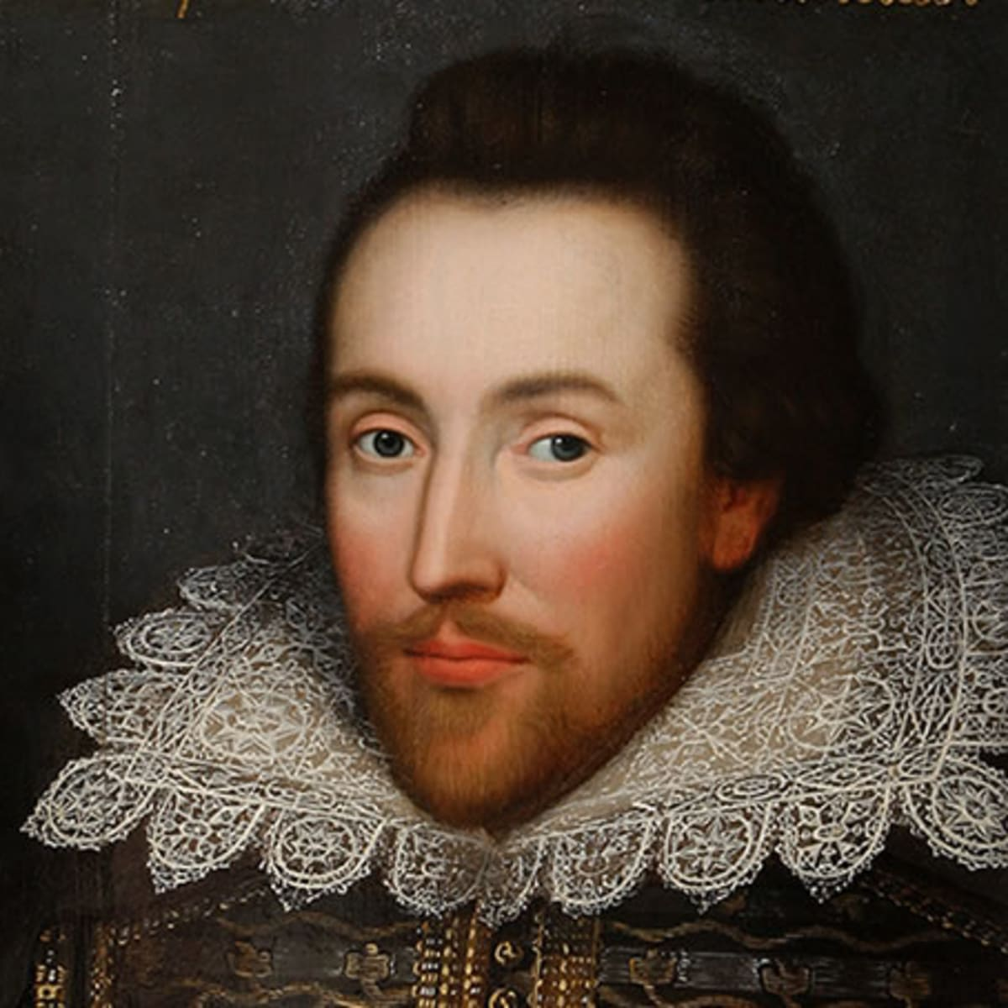
“I call for pen and ink,
and write my mind”

William Shakespeare
William Shakespeare, Shakespeare Birthplace Trust.

William Shakespeare became famous 200 years before Martin Van Buren was born. His poems, stories and plays are still read by people all over the world.

Martin Van Buren would have read Shakespeare and seen performances of his plays.

Shakespeare’s often mentioned the weather in his stories and plays, just like the author of the book you will hear read to you!

We hope you enjoy the story and your weather adventure guided by the famous
William Shakespeare.

Listen to a story about how a “Cloud became a Cloud” by Ron Hodgson on YouTube at:
https://www.youtube.com/watch?v=EVJQm0ZTeIQ

“And Then, in Dreaming,
The Clouds Methought
Would Open and Show
Riches Ready to Drop Upon me,
That when I waked, I cried to
Dream again.”
The Tempest by William Shakespeare

Make Your Own Cloud Headband!

- Materials Needed:
· 2 Sheets of Strong White Paper
· Scissors
· Cotton Balls and Glue
· Tape or Stapler and Staples
- Download:
· The Cloud Shape Template
- Instructions:
1. Download and cut out the cloud shape template.
2. Glue cotton balls on to one side of the cloud you cut out - for a fluffy effect.
3. Cut 2 strips of white paper from the second white sheet of paper.
4. Tape or staple the strips together to make one long strip of paper.
5. Take the long strip of paper and wrap it around your forehead.
6. Have a grown up help you staple or tape the ends together to keep the strip of paper in place.
7. Glue the cloud cut out to the front (fluffy side facing out) for a cloud headband.


Meteor Whaaaat?
A Meteor what? (pronounced: meet-ee-or)

A Meteorologist. (pronounced: meet – ee- or – all- ih – jist)

It’s not a planet; it’s a job! They study the weather.

You will often see Meteorologists on the news giving a temperature and weather report.

The information they provide us throughout the day tells us how we should dress when going outside.

If it wasn’t for Meteorologists, we might wear flip-flops when it’s freezing or leave our water bottles at home when it’s actually hot out and should have them.

If you think about it, Meteorologists help save lives!

- Learn more about the job of a Meteorologist by watching a video created by:

Meteorologist JD Rudd at 41 Action News in Kansas City, Missouri.

https://www.youtube.com/watch?v=qWWx3reC9qA

Weather Chart

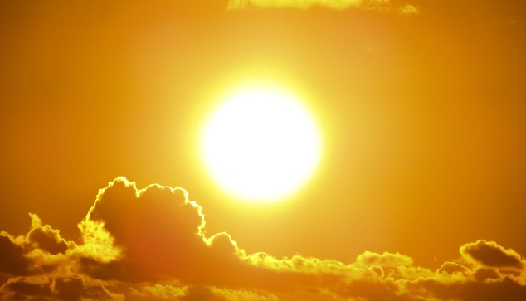
Sunny
The sun is shining brightly, like on a perfect summer day! Clouds may still be seen but there won’t be a lot of them.


Cloudy
Many clouds in the sky. Cloudy days are usually cooler than sunny days.

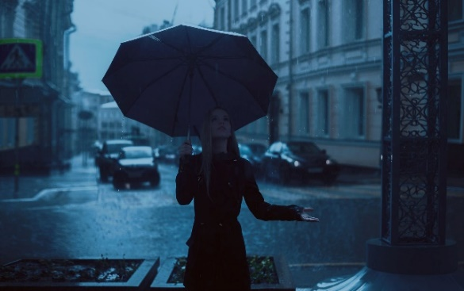
Rainy
Rain is water that falls from the clouds. A rainy day is a good time to curl up on the couch with your favorite book.

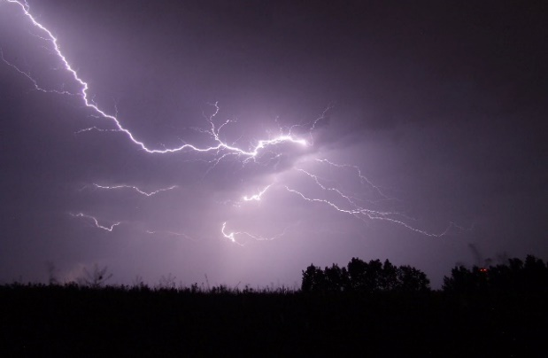
Thunderstorm
Heavy rain and wind with bangs in the sky,called thunder. You may see bright flashes of light - lightning. It may seem scary but is just a fact of nature.

More Weather


Windy
Wind is air around you that is moving fast enough to feel. A windy day can be sunny, cloudy, rainy, hot, or cold. A sunny and windy day is a perfect day to fly a kite!

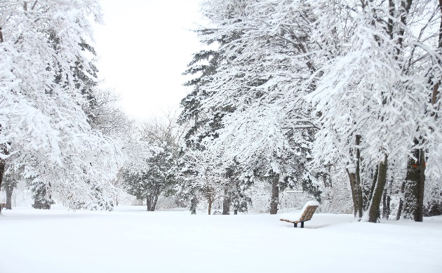
Snowy
Snow is frozen water that falls from clouds. Snowy days are when a lot of snow has fallen on the ground and real cold! Bundle up with a blanket and some hot chocolate.
Temperature


Hot
Tells us how warm something is. The sun, the beach, and summer are all things we think of when we hear the word ‘hot.’ This is what we call “flip flop weather”.

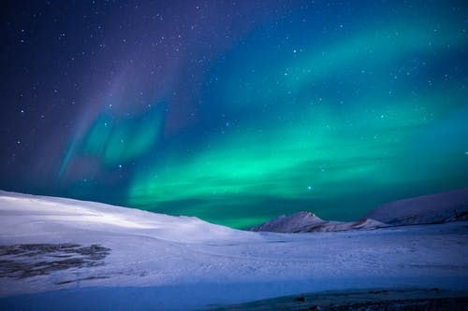
Cold
How cool something is. Winter, snow, and a freezer are all things that are cold. Don’t forget your scarf!


Think &
Predict


You have learned a little about weather and temperature, now let’s play a game using what you know.
Circle what you predict will be tomorrow’s weather.
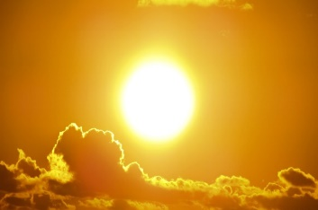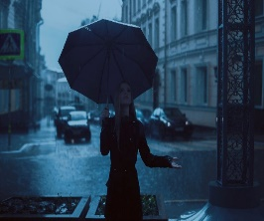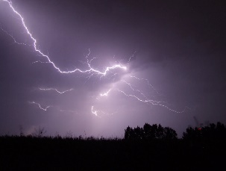
Sunny Cloudy Rainy Thunderstorms
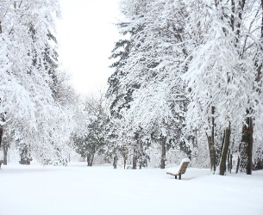
Ask a grown-up to help you find a weather report tomorrow and check to see if your weather prediction was correct.
Windy Snowy
Circle your guess for tomorrow’s temperature.


Hot Cold

Make Your Own
“Cloud In a Jar!” 
Materials Needed:
- Clear jar with a lid (Preferably a Mason jar, they withstand heat.)
- Hot water (does not need to be boiling)
- Ice cubes – about 4, or as much as the lid can hold.
- Hairspray (can be done without, but hairspray sticks to the moisture in the jar the same way ash does in the atmosphere. This is relevant for the story on the next page.)
- Cloud Chart in Weather Journal
Instructions:
1. Remove lid and fill your jar no more than half full. Swirl it around to warm up the jar.
2. Place the lid upside down (bottom facing up) and set the ice cubes on it.
3. Wait about half a minute then quickly remove the lid, spray some hair spray in the jar and quickly reset the lid with the ice still on it.
4. Watch the cloud form inside the jar!
6. After a few minutes, lift the lid and let your cloud float out of the jar into the air!
7. Compare the cloud to the chart in your journal.
8. What kind of cloud does yours look like? ________________________________

4 Kinds of Clouds

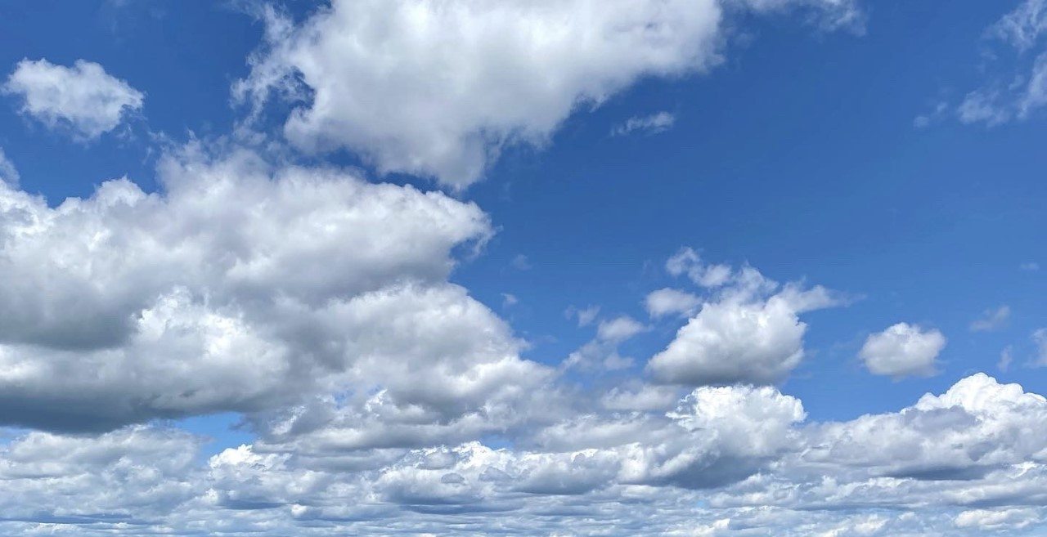
Cumulus
(Pronounced: Qum-Mew-Luss)
Clouds with puffy, flat bottoms that are low in the sky. They usually mean the weather will be nice!

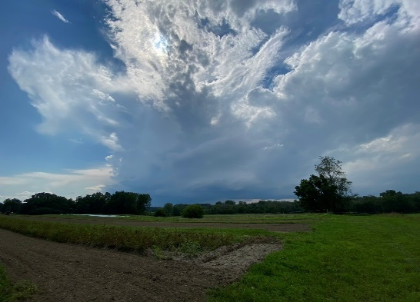
Cumulonimbus (Pronounced: Cuem-Mew-Low-Nim-Bus)
These are thunderstorm clouds. They look like very tall cumulus clouds but often are darker in color.

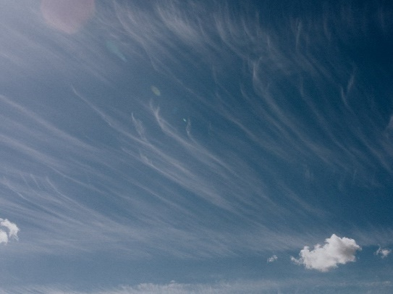
Cirrus
(Pronounced: Sear-us)
Thin, white clouds that are very high in the sky. They are made of ice crystals and are a sign of nice weather.


Stratus
(Pronounced: Strat-Us)
Clouds that are wide blankets or layers of clouds. They are low in the sky and they are often a sign of rain!
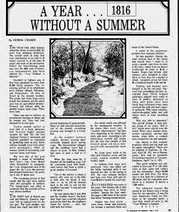

In 1814 a volcano erupted on the continent of Asia, with another erupting on the same continent the following year, in 1815.

The ash from the two volcanic eruptions formed a red fog that prevented the sun from shining.

The weather was so unusual; 1816 was remembered as, “a year without a summer,” because the lack of sun created cold weather around the world.

Martin Van Buren was living in Albany, New York, with his family during that very cold year.

We don't know how they felt about the weather, but the Van Buren children probably did not swim much that summer. The weather records for New York show it snowed in June and in July the ground was still frozen!

It took another two years for weather around the world to return to normal!

How would you feel if your Summer turned into Winter?
Write your answer, or have a grown-up write it, on the lines below:
_______________________________________________________
_______________________________________________________
_______________________________________________________
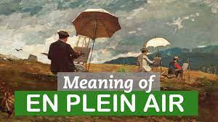
Have you ever taken your crayons or paints outside to create a picture from
start to finish?
If you have, then you have painted or drawn it
“En Plein Air”
(Pronounced: On – plane – air)
That’s French for:
“In the open air.”
Not only is it fun, but you get to enjoy fresh air while getting ideas from nature.

The best way to capture what the clouds look like where you live is to go outside and draw them ‘En plein air’
What you will need:
- The cloud paper on the next page.
- A book or something strong that is larger than the piece of paper to make it easy to draw.
- Crayons or paints.
- A blanket or bath towel.
- Your cloud headband – artists often wear things they made

Step out into the open air and observe (Pronounced: ub-zerv. It means to look at closely, to study it) the clouds.
What do you see?
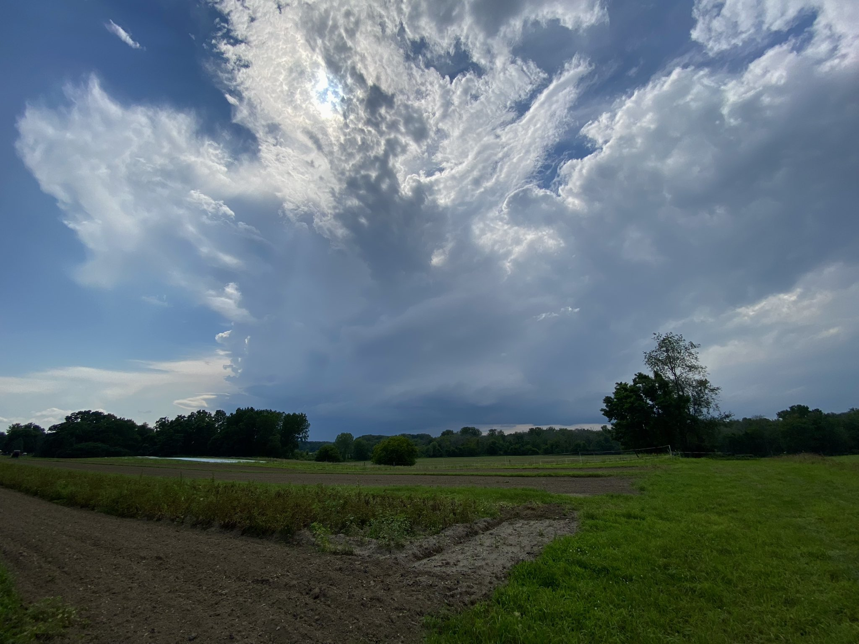
Thunderstorm
Sun
Windy
Cloud Quiz
1. True or False? A Meteorologist studies the weather?
2. A Thermometer is used to measure what?
A. Temperature
B. Wind
C. Rain
D. A dog’s tail
3. True or False?
Cirrus clouds are thin white clouds very high in the sky.
4. What caused Martin Van Buren’s “Year without a Summer?”
A. Floods
B. A Volcano
C. A Hurricane
D. Too much ice cream
5. Draw a line connecting the picture on the right with the correct weather name.
